Week 1 Penetration Testing Report
Full Name: Atharva Jagdale
Program: HCPT
Date: 13-02-2025

Introduction
This report document hereby describes the proceedings and results of a Black Box security assessment conducted against Week 2 Labs. The report hereby lists the findings and corresponding best practice mitigation actions and recommendations.
- Objective
The objective of the assessment was to uncover vulnerabilities in the Week 2 Labs and provide a final security assessment report comprising vulnerabilities, remediation strategy, and recommendation guidelines to help mitigate the identified vulnerabilities and risks during the activity.
- Scope
This section defines the scope and boundaries of the project.
{HTML Injection}, {Cross-Site Scripting}
Application Name
- Summary
Outlined is a Black Box Application Security assessment for Week 2 Labs.

Total number of Sub-labs: 8 Sub-labs

High | Medium | Low
1 | 3 | 4

High - Number of Sub-labs with hard difficulty level Medium - Number of Sub-labs with medium difficulty level, Low - Number of Sub-labs with Easy difficulty level

  - {HTML Injection}
    - {HTML’s are easy!}

Reference | Risk Rating
HTML’s are easy! | Low
Tools Used
Google chrome
Vulnerability Description
I found this vulnerability by using basic HTML tags i.e., h1 tag.
How It Was Discovered
Manual Analysis.
Vulnerable URLs
https://labs.hacktify.in/HTML/html_lab/lab_1/lab_1.php
Consequences of not Fixing the Issue
This can lead to managing and accessing other web pages and it can lead to phishing other users.
Suggested Countermeasures
Sanitize the input by validating canonical tags (<>) and slash (/). or < > ( ) ‘ “ / \ * ; : = { }.
References
I used basic knowledge of HTML to discover this vulnerability.
Payload Used
<h1>Hello bunny</h1>
Proof of Concept
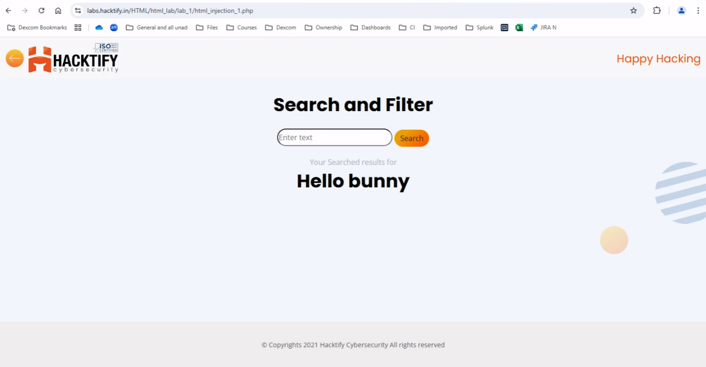

    - {Let me store them}

Reference | Risk Rating
Let me store them | Low
Tools Used
Google chrome
Vulnerability Description
I found this vulnerability by trying multiple HTML tags on different input fields. Here I can run
every HTML valid code to inject malicious code.
How It Was Discovered
Manual Analysis.
Vulnerable URLs
https://labs.hacktify.in/HTML/ html_lab/lab_2/lab_2.php
Consequences of not Fixing the Issue
To steal another person's identity.
Suggested Countermeasures
Sanitize the input by validating canonical tags (<>) and slash (/). or < > ( ) ‘ “ / \ * ; : = { }.
References
https://owasp.org/www-project-web-security-testing-guide/latest/4-Web_Application_Security_Testin g/11-Client-side_Testing/03-Testing_for_HTML_Injection
Payload Used
"><h1>Hello Bunny</h1>

Proof of Concept
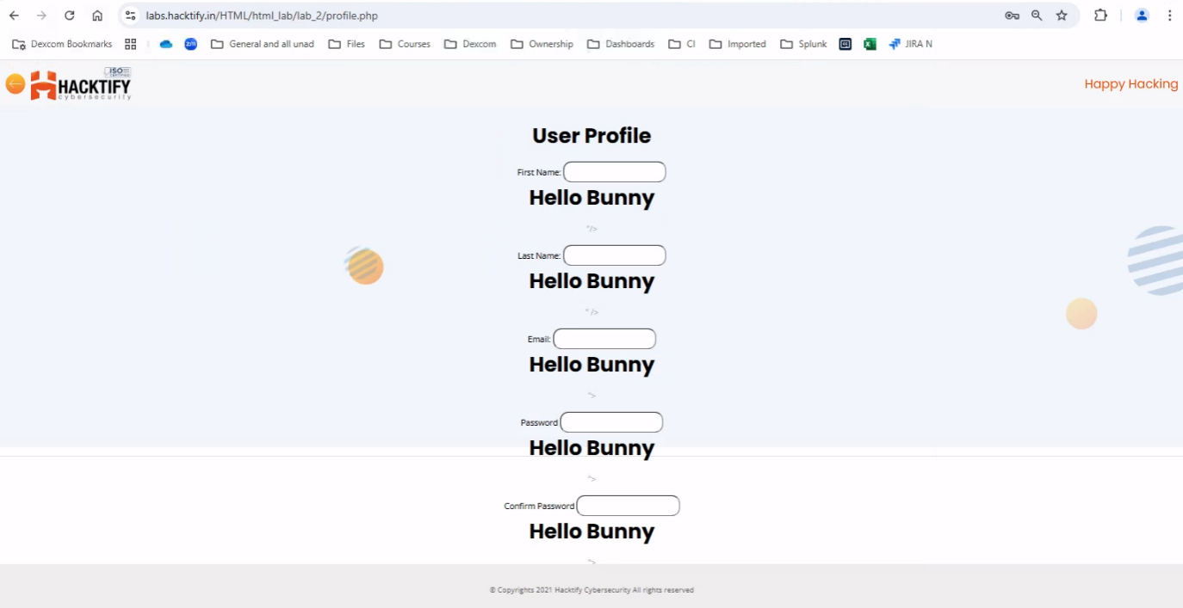

    - {File names are also vulnerable}

Reference | Risk Rating
File names are vulnerable | Low
Tools Used
Google chrome and Burp Suite
Vulnerability Description
I found this vulnerability by intercepting a web app on burpsuite and changing the filename on it to
back on the web to a successful run.
How It Was Discovered
Manual Analysis as well as automated analysis
Vulnerable URLs
https://labs.hacktify.in/HTML/ html_lab/lab_3/lab_3.php
Consequences of not Fixing the Issue
Malicious file names may distract the user and it can cause the user to do something illegal or wrong on the web.
Suggested Countermeasures
Sanitize the input by validating canonical tags (<>) and slash (/). or < > ( ) ‘ “ / \ * ; : = { } and it should not accept any of these tags by external resources also.
References
https://owasp.org/www-project-web-security-testing-guide/latest/4-Web_Application_Security_Testin
g/11-Client-side_Testing/03-Testing_for_HTML_Injection
Payload Used
<h1>whatsapp,you are hacked.ps1</h1>

Proof of Concept
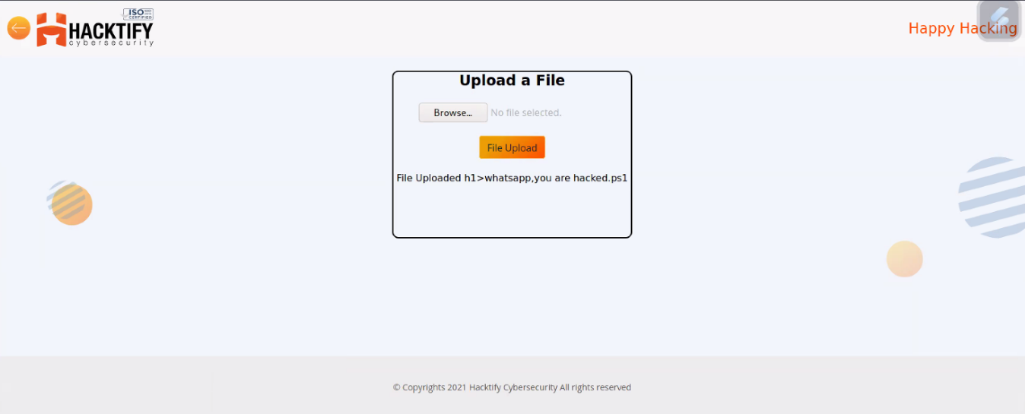

    - {File content and HTML Injection a perfect pair}

Reference | Risk Rating
File content and HTML Injection are a perfect pair | Medium
Tools Used
Google chrome
Vulnerability Description
I found this vulnerability by just uploading malicious files in the file uploading section with different file extensions and containing malicious code in it.
How It Was Discovered
Manual Analysis
Vulnerable URLs
https://labs.hacktify.in/HTML/ html_lab/lab_4/lab_4.php
Consequences of not Fixing the Issue
It can lead to taking down an entire website and the website will show wrong data content on
the website.
Suggested Countermeasures
Sanitization of file extensions that it should accept only required files with valid and specified file extensions
References
https://owasp.org/www-project-web-security-testing-guide/latest/4-Web_Application_Security_Testin
g/11-Client-side_Testing/03-Testing_for_HTML_Injection
Payload Used
<h1>You are Hacked</h1> in a text file and then uploaded over there

Proof of Concept
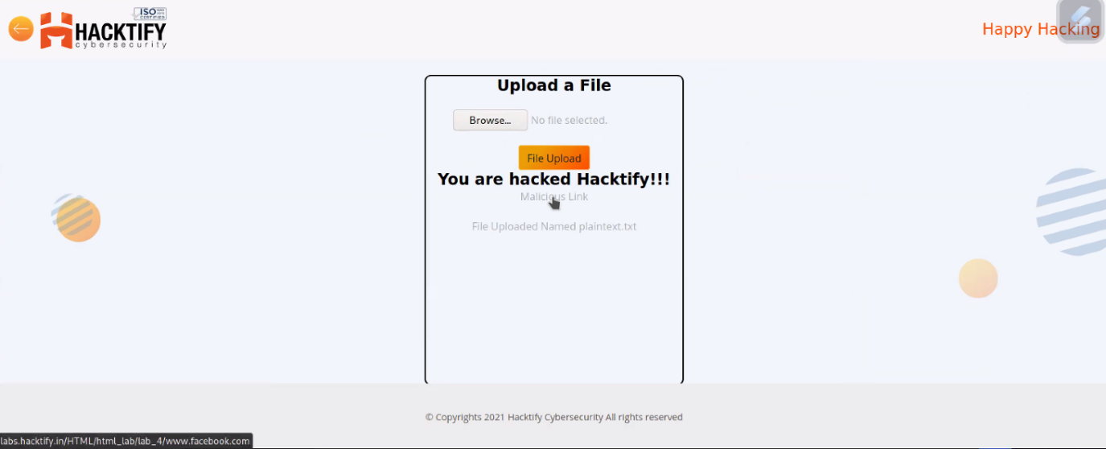

    - {Injecting HTML using URL}

Reference | Risk Rating
Injecting HTML using URL | Medium
Tools Used
Google chrome
Vulnerability Description
I found this vulnerability by tampering the actual website of the code and injecting valid HTML code as malicious code or payload
How It Was Discovered
Manual Analysis
Vulnerable URLs
https://labs.hacktify.in/HTML/ html_lab/lab_5/lab_5.php
Consequences of not Fixing the Issue
It can allow attackers to modify the URL and modify the web pages
Suggested Countermeasures
Invalid URL should not work or should display errors to the user
References
https://owasp.org/www-project-web-security-testing-guide/latest/4-Web_Application_Security_Testin
g/11-Client-side_Testing/03-Testing_for_HTML_Injection
Payload Used
?<h1>Hacked Website</h1> in the URL

Proof of Concept
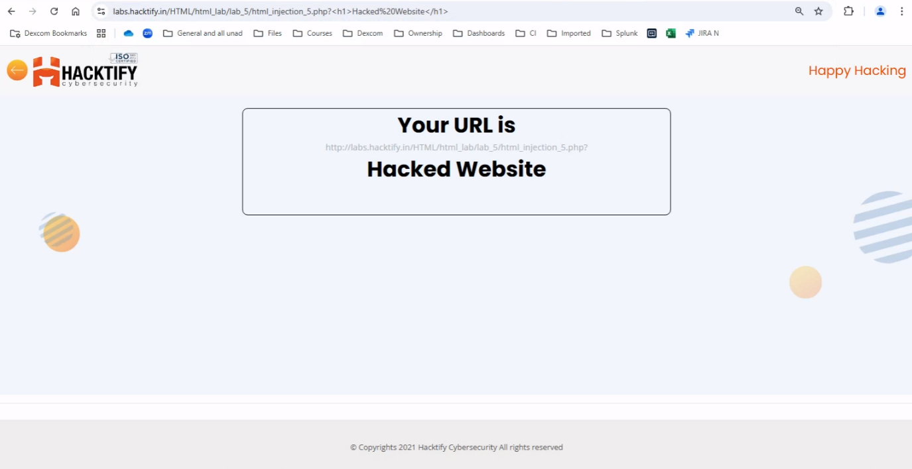

    - {Encode it}

Reference | Risk Rating
Encode it | High
Tools Used
Google chrome
Vulnerability Description
I found this vulnerability by entering basic HTML valid code by encoding it into URL encoder
How It Was Discovered
Manual Analysis and automated analysis
Vulnerable URLs
https://labs.hacktify.in/HTML/ html_lab/lab_6/lab_6.php
Consequences of not Fixing the Issue
This can lead to managing and accessing other web pages and it can lead to phishing other users.
Suggested Countermeasures
Sanitize the input by validating canonical tags (<>) and slash (/). or < > ( ) ‘ “ / \ * ; : = { } also encoding with the help of other external tools
References
https://owasp.org/www-project-web-security-testing-guide/latest/4-Web_Application_Security_Testin g/11-Client-side_Testing/03-Testing_for_HTML_Injection
Payload Used
<h1?Hello bunny. You hacked it!!</h1> in URL Encoder

Proof of Concept
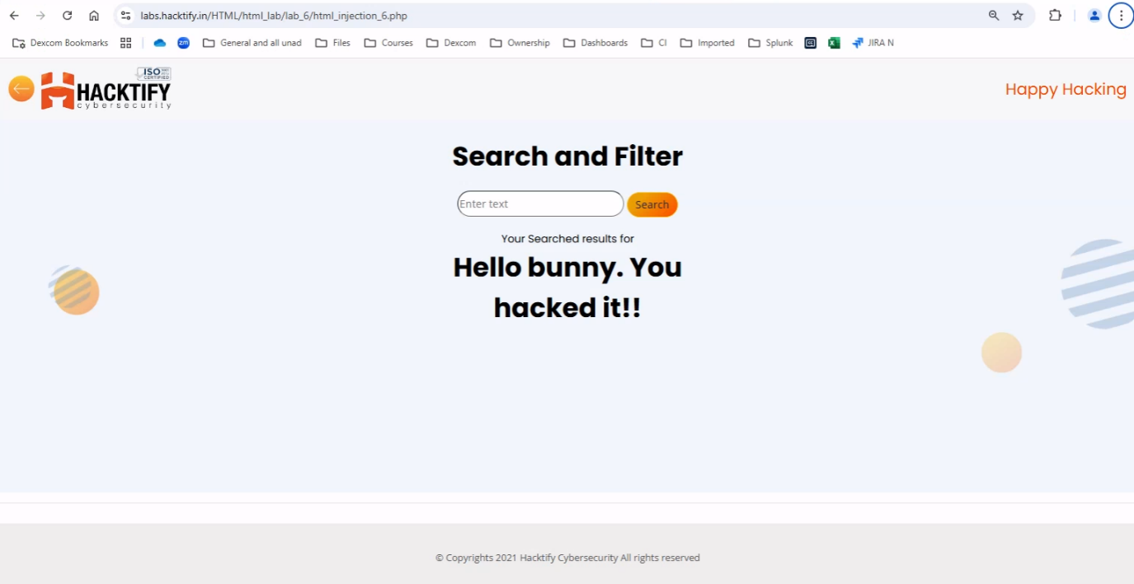

  - {Cross-Site Scripting}
    - {Let’s do it!}

Reference | Risk Rating
Let’s Do IT! | Low
Tools Used
Google Chrome
Vulnerability Description
I found this vulnerability by entering simple javascript code into the client side reflection field, i.e., i successfully performed reflected xss.
How It Was Discovered
Manual Analysis
Vulnerable URLs
labs.hacktify.in/HTML/xss_lab/lab_1/lab_1.php
Consequences of not Fixing the Issue
XSS enables an attacker to inject client-side code, so with this, an attacker will be able to capture client-side cookies which can capture account credentials of any user.
Suggested Countermeasures
Developers must sanitize the input of any user by denying entry of any tag or any special character.
References
I found this basic vulnerability by entering a basic JavaScript tag. So, I did not get any help.
Payload Used
<script>alert(27)</script>
Proof of Concept

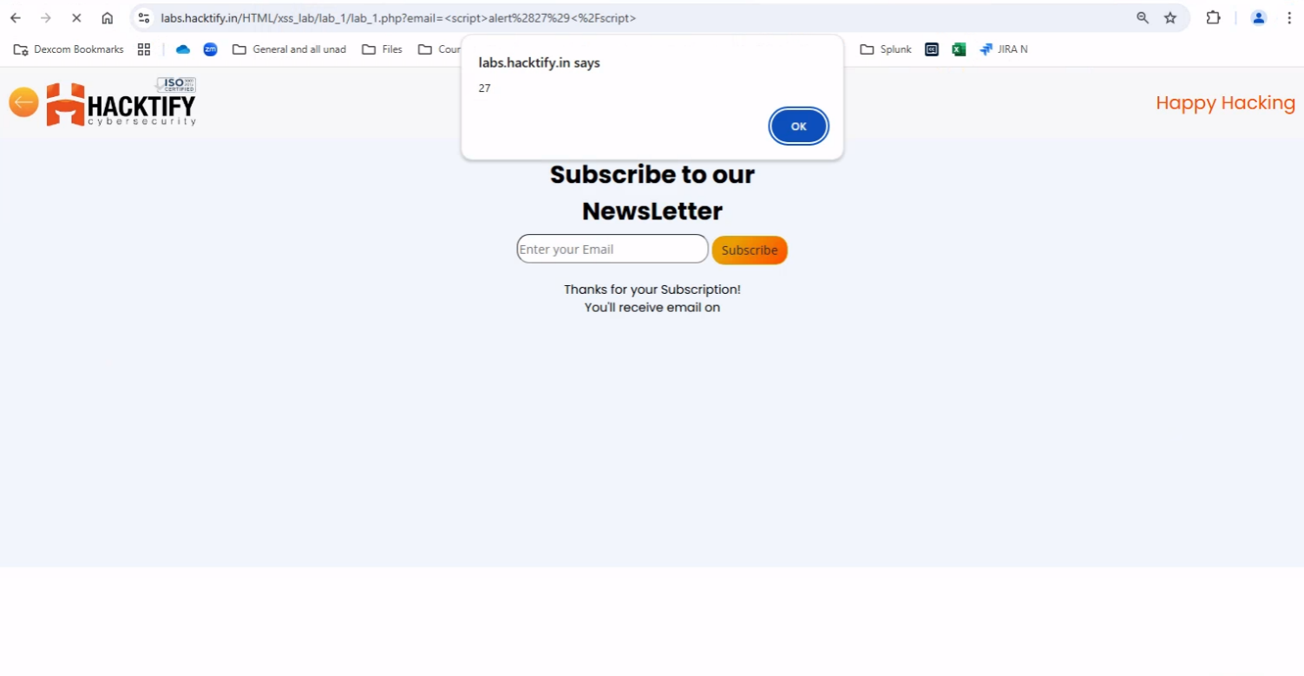
2.2. {Balancing is important in life}

Reference | Risk Rating
Balancing is important in life | Low
Tools Used
Google chrome
Vulnerability Description
I found this vulnerability by modifying the URL after getting valid output as actually developed. Also, it will allow an attacker to carry out any action that the user is able to perform.
How It Was Discovered
Manual Analysis
Vulnerable URLs
labs.hacktify.in/HTML/xss_lab/lab_2/lab_2.php
Consequences of not Fixing the Issue
Carry out any action that the user can perform.
Suggested Countermeasures
Developers must sanitize the input of any user by denying entry of any tag or any special character. And
Also, illegal links of any web page should not display any valid output.
References
https://github.com/payloadbox/xss-payload-list
Payload Used
"/><script>alert("Hacked by Bunny")</script>

Proof of Concept
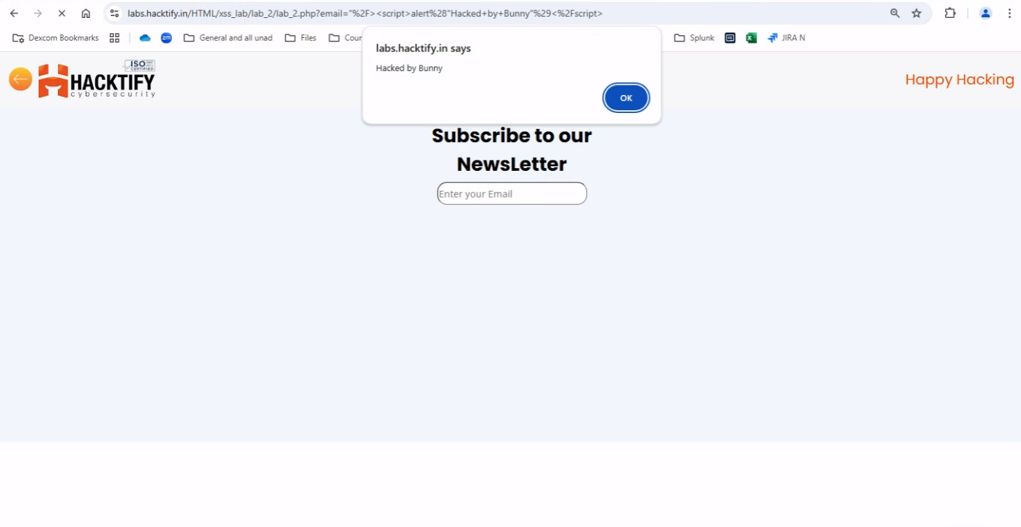

2.3. {XSS is everywhere!}

Reference | Risk Rating
XSS is everywhere! | Low
Tools Used
Google chrome
Vulnerability Description
I found this vulnerability by modifying the URL after getting valid output as actually developed. Here, the developer has given validation while developing this web page as the text field must contain a valid email address which will end with “@gmail.com”. If any other input is entered, then an error message will display called “Enter a valid email address”. So, to bypass this I simple inserted my payload which will end with provided validation for input, i.e., “@gmail.com”
How It Was Discovered
Manual Analysis
Vulnerable URLs
labs.hacktify.in/HTML/xss_lab/lab_3/lab_3.php
Consequences of not Fixing the Issue
Carry out any action that the user can perform.
Suggested Countermeasures
Developers must sanitize the input of any user by denying entry of any tag or any special character if it is not a valid entry for that text field.
References
https://github.com/payloadbox/xss-payload-list
Payload Used
@gmail.com<script>alert("Hello From Bunny in Lab 3")</script>

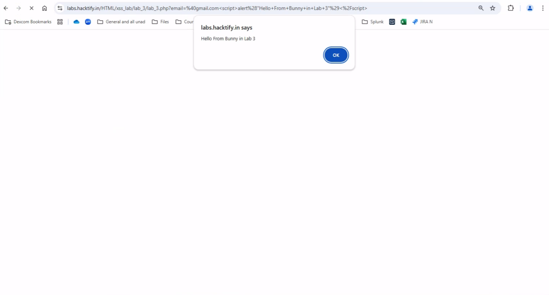
Proof of Concept

2.4. {Alternatives are a must!}

Reference | Risk Rating
Alternatives are a must | Medium
Tools Used
Google chrome
Vulnerability Description
I found this vulnerability by modifying the URL after getting valid output as actually developed. But, here the developer has sanitized the tag which is commonly used in JavaScript, i.e., alert(). So, to bypass this situation, I used the confirm() tag and I successfully got what I expected. Also, I am able to successfully run prompt() tag instead of alert() and alternative of confirm()
How It Was Discovered
Manual Analysis
Vulnerable URLs
labs.hacktify.in/HTML/xss_lab/lab_4/lab_4.php
Consequences of not Fixing the Issue
Carry out any action that the user can perform.
Suggested Countermeasures
Such web pages must be sanitized by denying the input of JavaScript tags which are not required in the text fields.
References
https://github.com/payloadbox/xss-payload-list
Payload Used
"/><script>confirm("This is also hacked by bunny")</script>@gmail.com

Proof of Concept

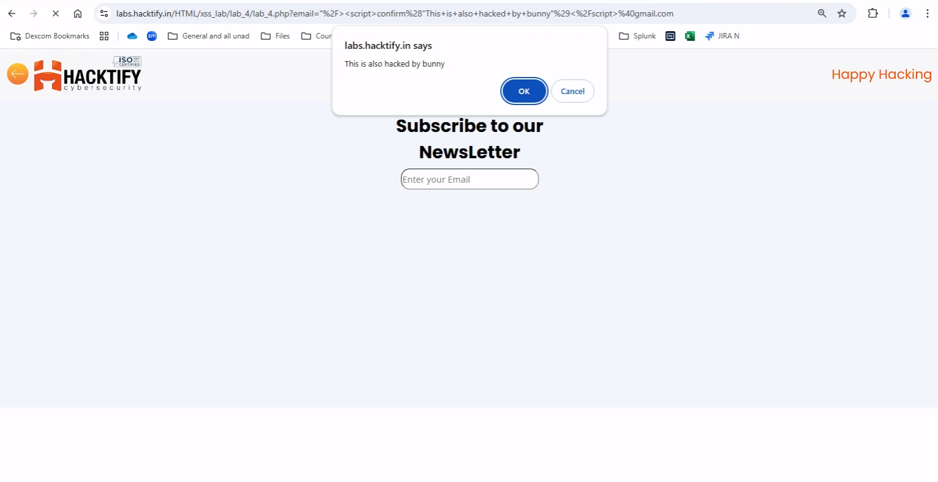

2.5. {Developer hates script!}

Reference | Risk Rating
Developers hate scripts! | Hard
Tools Used
Google chrome
Vulnerability Description
I found this vulnerability by using different javascript tags like <img>, <svg>, etc.
How It Was Discovered
Manual Analysis
Vulnerable URLs
labs.hacktify.in/HTML/xss_lab/lab_5/lab_5.php
Consequences of not Fixing the Issue
Carry out any action that the user can perform.
Suggested Countermeasures
Developers must sanitize the input of any user by denying entry of any tag or any special character if it is not a valid entry for that text field.
References
https://github.com/payloadbox/xss-payload-list
Payload Used
"/><img src=bunny onerror=alert(27) >

Proof of Concept

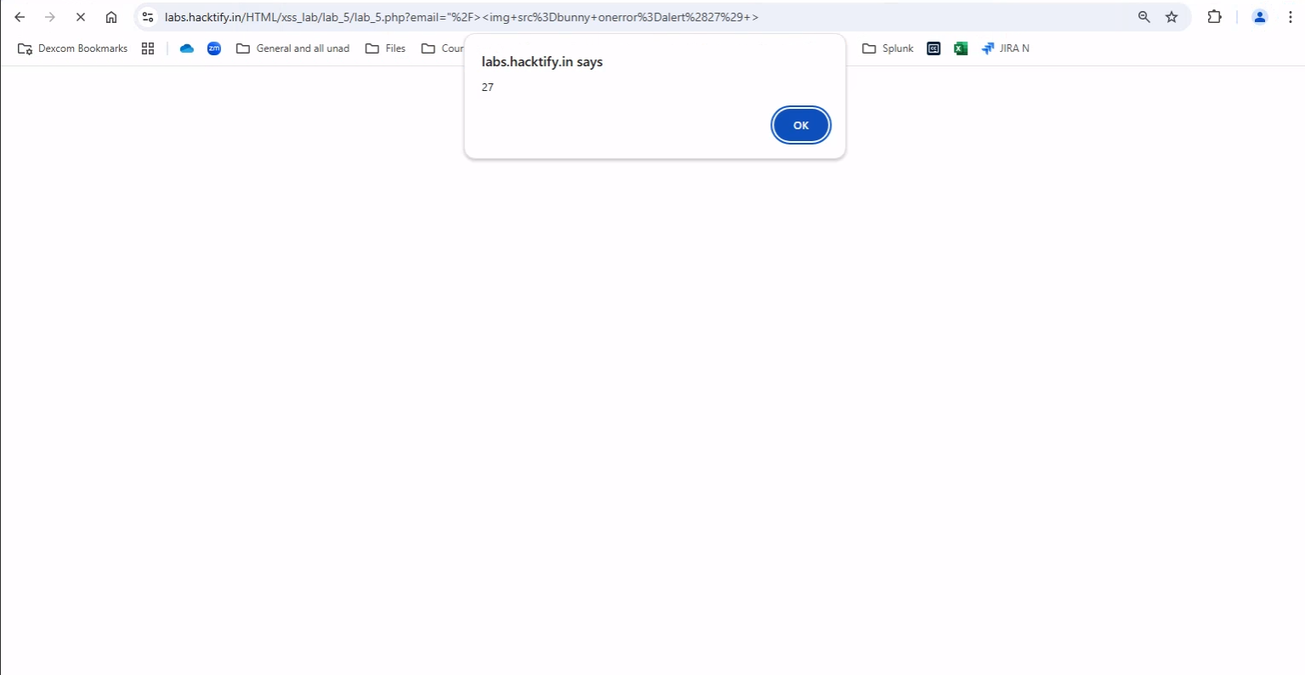

2.6. {Change the variation!}

Reference | Risk Rating
Change the variation! | Hard
Tools Used
Google chrome
Vulnerability Description
I found this vulnerability by merging two different tags within a single command as payload to bypass the situation which the developer has created. I used, <script> tag in which I used <svg> tag to bypass it.
How It Was Discovered
Manual Analysis
Vulnerable URLs
labs.hacktify.in/HTML/xss_lab/lab_6/lab_6.php
Consequences of not Fixing the Issue
Carry out any action that the user can perform.
Suggested Countermeasures
Developers must sanitize the input of any user by denying entry of any tag or any special character if it
is not a valid entry for that text field.
References
https://github.com/payloadbox/xss-payload-list
Payload Used
"/><script>confirm(<svg xmlns="https://www.theyfuckerme.com" onload=alert(document.domain)>) </script>

Proof of Concept

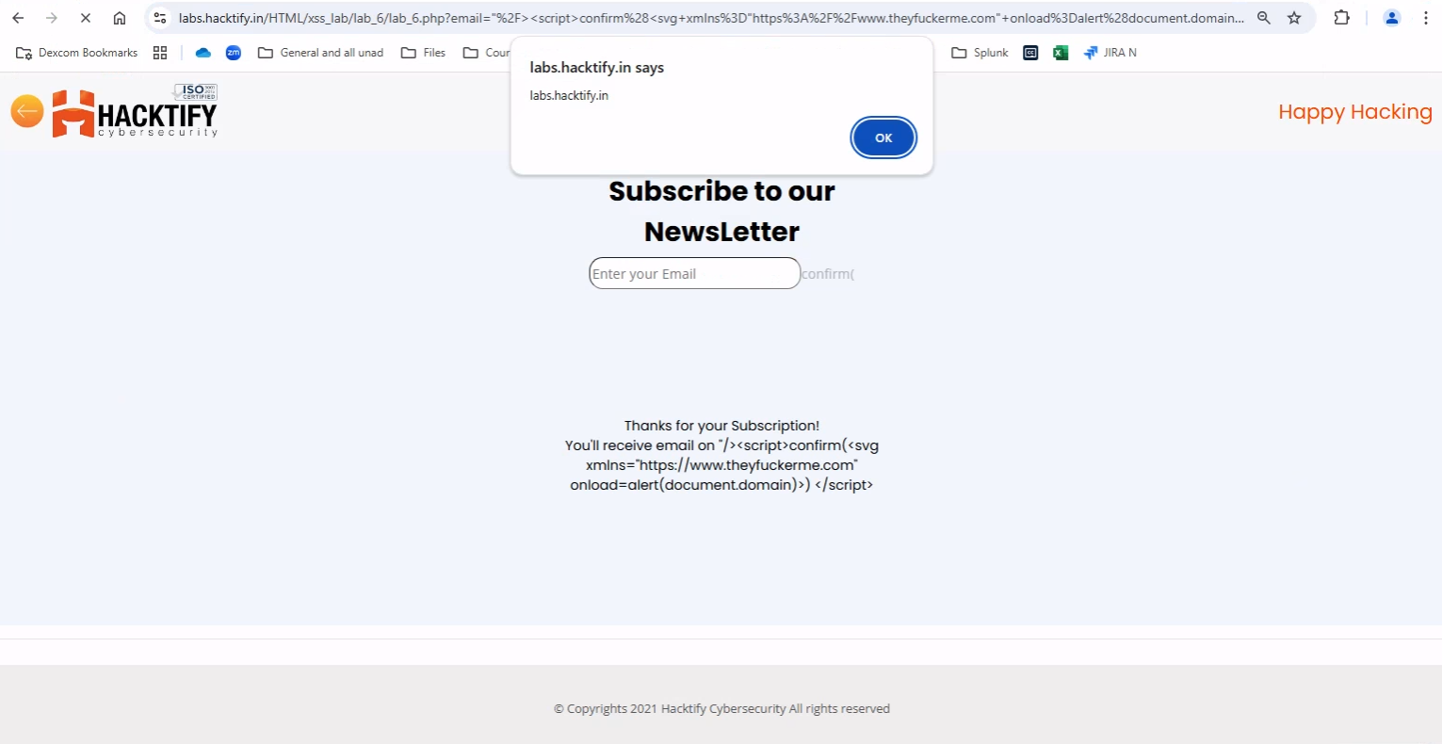

2.7. {Encoding is the key?}

Reference | Risk Rating
Encoding is the key? | Medium
Tools Used
Google chrome
Vulnerability Description
This vulnerability was found by URL encoding a simple javascript command with the help of Burp Suite.
How It Was Discovered
Manual Analysis and Automated Analysis
Vulnerable URLs
labs.hacktify.in/HTML/xss_lab/lab_7/lab_7.php
Consequences of not Fixing the Issue
Carry out any action that the user can perform.
Suggested Countermeasures
Filtering inputs at the arrival of input data which will run through text fields.
References
https://github.com/payloadbox/xss-payload-list
Payload Used
Plain Text - "/><script>alert("your love, BUNNY!!")</script>
Encoded Payload - %22%2F%3E%3Cscript%3Ealert%28%22your%20love%2C%20BUNNY%21%21%22%29%3C%2Fscript%3E

Proof of Concept

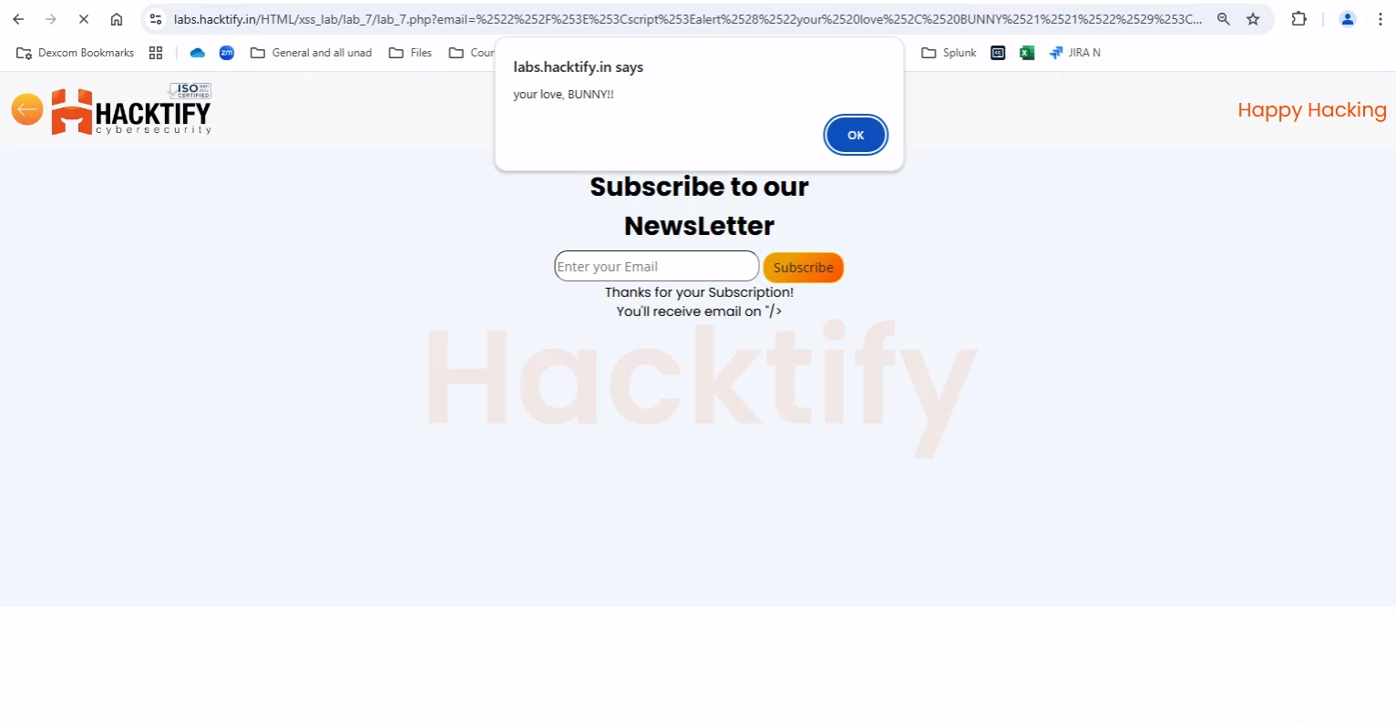

2.8. {XSS with file upload (file name)}

Reference | Risk Rating
XSS with file upload (file name) | Low
Tools Used
Google chrome and Burp Suite
Vulnerability Description
I found this vulnerability by intercepting a file upload request onto Burp Suite tool and renaming the file name to insert payload into filename to bypass all the validation to load payload into the web pages and database to store payload into it.
How It Was Discovered
Manual Analysis and Automated Analysis
Vulnerable URLs
labs.hacktify.in/HTML/xss_lab/lab_8/lab_8.php
Consequences of not Fixing the Issue
Carry out any action that the user can perform.
Suggested Countermeasures
Using appropriate HTTP headers and using Content Security Policy
References
https://github.com/payloadbox/xss-payload-list
Payload Used
"/><img src=bunny onerror=alert(27) >

Proof of Concept

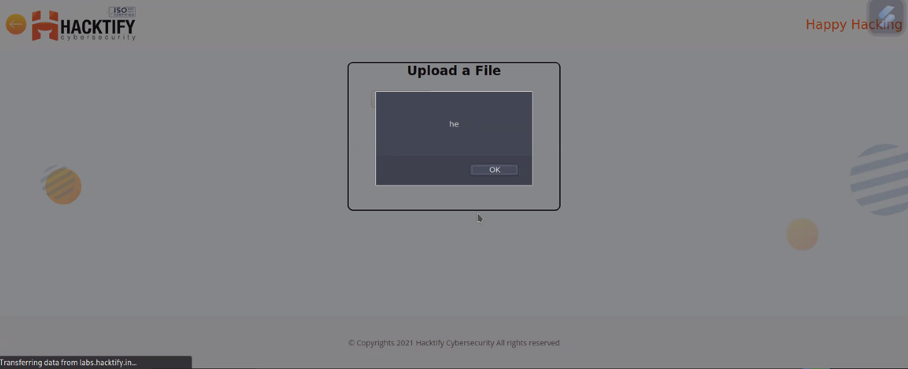

2.9. {XSS with file upload (file content)}

Reference | Risk Rating
XSS with file upload (file content) | Medium
Tools Used
Google chrome
Vulnerability Description
I found this vulnerability by uploading a malicious code file into the file upload section. In malicious code, I used <script> tag to design a malicious code.
How It Was Discovered
Manual Analysis
Vulnerable URLs
labs.hacktify.in/HTML/xss_lab/lab_9/lab_9.php
Consequences of not Fixing the Issue
Carry out any action that the user can perform.
Suggested Countermeasures
Using appropriate HTTP headers and using Content Security Policy
References
https://github.com/payloadbox/xss-payload-list
Payload Used
<script>alert(document.domain)</script>

Proof of Concept

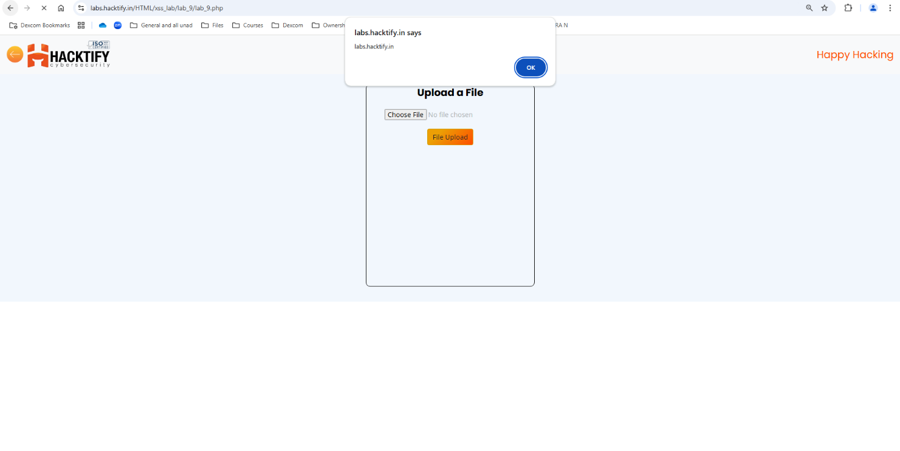

2.10. {Stored Everywhere}

Reference | Risk Rating
Stored Everywhere | Low
Tools Used
Google chrome
Vulnerability Description
I found this vulnerability by registering my into register web page. I inserted a simple <script> tag in all fields which are required to fill for registration. After registration, I tried logging in into the webpage and after the login request, I was able to verify that I successfully implemented a stored XSS attack. Here, these credentials will be stored into the database which can affect other used credentials as well as other database related features.
How It Was Discovered
Manual Analysis
Vulnerable URLs
labs.hacktify.in/HTML/xss_lab/lab_10/lab_10.php
Consequences of not Fixing the Issue
Carry out any action that the user can perform.
Suggested Countermeasures
Using appropriate HTTP headers and using Content Security Policy
References
https://github.com/payloadbox/xss-payload-list
Payload Used
- "/><script>alert("Issue in FNAME")</script>
- "/><script>alert("Issue in LNAME")</script>
- "/><script>alert("Issue in EMAIL")</script>
- "/><script>alert("Issue in PASS")</script>

Proof of Concept

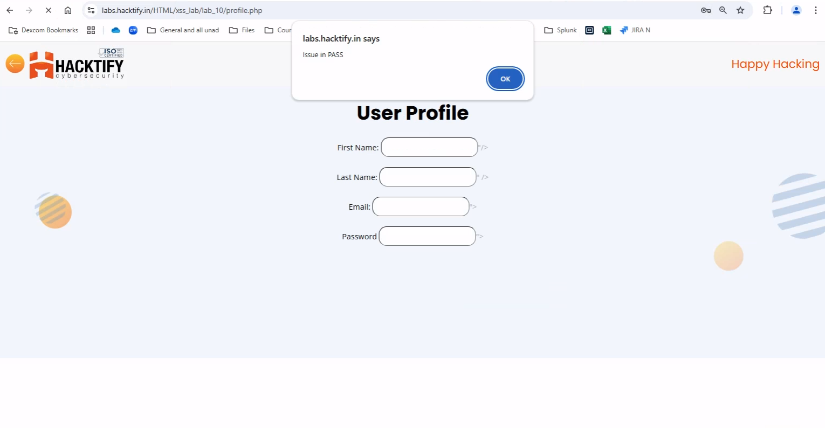

2.11. {DOM’s are Love}

Reference | Risk Rating
DOM’s are Love | Hard
Tools Used
Google chrome
Vulnerability Description
I found this vulnerability by inspecting the source code of the web page and finding out what variables are used in this section. And later on tried to load payload using <img> tag.
How It Was Discovered
Manual Analysis
Vulnerable URLs
labs.hacktify.in/HTML/xss_lab/lab_11/lab_11.php
Consequences of not Fixing the Issue
Carry out any action that the user can perform.
Suggested Countermeasures
Using appropriate HTTP headers and using Content Security Policy
References
https://github.com/payloadbox/xss-payload-list
Payload Used
Payload - name=bunny<img src=bugs onerror=alert("buggeebunny")>
URL - https://labs.hacktify.in/HTML/xss_lab/lab_11/lab_11.php?name=bunny%3Cimg%20src=bugs%20onerror=alert(%22buggeebunny%22)%3E

Proof of Concept

